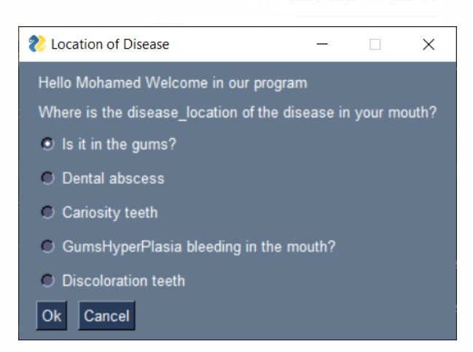

2

